NAME: CENNDY M. NIELES SECTION:CPE11S1
INSTRUCTOR: JIMLORD QUEJADO
ACTIVITY: USING PSEUDO-CODE STATEMENT AND FLOWCHART SYMBOLS
Problem 1.
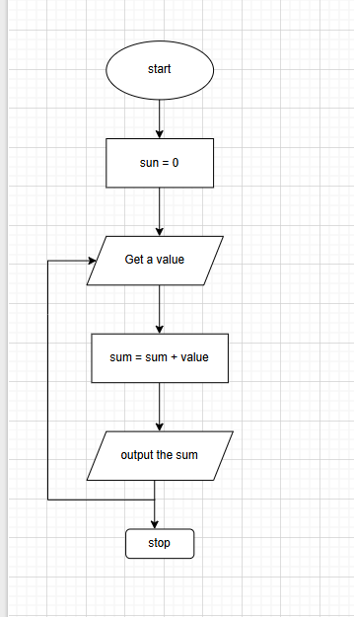
Problem 2

Finite Algorithm: Stop When -1 is Found
Step 1: Start
Step 2: Initialize sum ← 0
Step 3: Get a value
Step 4: If value = -1, go to Step 7
Step 5: Add value to sum → sum ← sum + value
Step 6: Go to Step 3
Step 7: Output sum
Step 8: Stop

Activity 1.
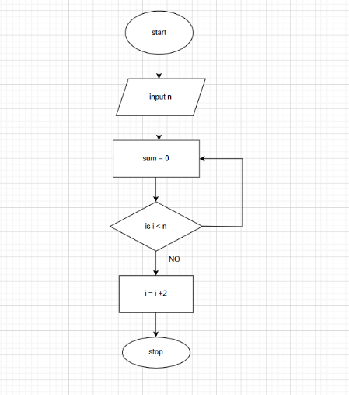

2.Algorithm to Read 100 Numbers and Display the Sum

Step 1: Start
Step 2: Initialize sum ← 0
Step 3: Initialize count ← 1
Step 4: Repeat while count ≤ 100
→ Read number
→ sum ← sum + number
→ count ← count + 1
Step 5: Output sum
Step 6: Stop

3. Algorithm to Read Two Numbers and Display the Largest
Step 1: Start
Step 2: Read num1, num2
Step 3: If num1 > num2
→ Output num1
Else
→ Output num2
Step 4: Stop

4.Algorithm to Read Two Numbers and Display the Smallest
Step 1: Start
Step 2: Read num1, num2
Step 3: If num1 < num2
→ Output num1
Else
→ Output num2
Step 4: Stop

5. Algorithm to Read Three Numbers and Display the Largest
Step 1: Start
Step 2: Read num1, num2, num3
Step 3: Initialize max ← num1
Step 4: If num2 > max, then max ← num2
Step 5: If num3 > max, then max ← num3
Step 6: Output max
Step 7: Stop

6. Algorithm to Read 100 Numbers and Display the Largest
Step 1: Start
Step 2: Initialize count ← 1
Step 3: Read the first number, set max ← number
Step 4: Repeat while count < 100
→ Read number
→ If number > max, then max ← number
→ count ← count + 1
Step 5: Output max

